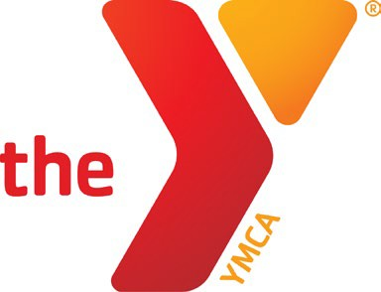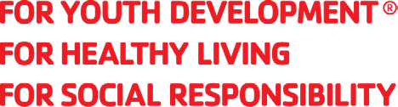

BATH AREA FAMILY YMCA JOB DESCRIPTION
Job Title: Grants Manager Revision Date: 04/05/2023

Status: Full time, Exempt Reports to: Chief Development Officer Location: Bath Area Family YMCA

POSITION SUMMARY:
This position supports the work of the Bath Area Family YMCA, a leading nonprofit and charitable organization committed to strengthening community through youth development, healthy living and social responsibility.
The Grants Manager works closely with the Chief Development Officer and senior team to lead and maximize the organization’s grants revenue and ensure ongoing funding sustainability. The Grants Manager is responsible for pre-grant research, grant writing, coordination of grant applications and post-award support for the two-branch association and current capital campaign.

ESSENTIAL FUNCTIONS:
- Identify viable annual and capital grant opportunities that align with the YMCA’s mission and strategic goals. Research potential funders and funding opportunities.
- Interpret and share information on federal, state, and private funding opportunities.
- Work with the Chief development Officer and program staff to match needs with potential funding resources.
- Coordinate with staff to draft grant proposals and budgets.
- Maintain system to track application activities, compliance, reporting and implementation of grant deliverables.
- Coordinate with Marketing Director to communicate community benefit and Y impact.
- Support stewardship to funders regarding grant awards and the management and monitoring of the funders’ requirements for recognition.
- Perform other related job duties as assigned.

QUALIFICATIONS:
  - Able to quickly gain an in-depth understanding of the Y organization, departments and functions.
  - Organized, with excellent attention to detail.
  - Excellent problem solving, analytical, writing and editing skills.
  - Ability to strategize, develop schedules, work with volunteers, and meet deadlines.
  - Excellent interpersonal skills with the ability to develop and maintain professional relationships.
  - Proficient in identifying grant opportunities through research and outreach.
  - Ability to develop and use spreadsheets and standard business software systems.
  - Bachelor’s degree or equivalent in education/experience.
  - One to two years of successful experience in grant writing preferred.
  - Ability to collect and use data to establish facts and draw valid conclusions.

OUR CULTURE:
Our mission and core values are brought to life by our culture. In the Y, we strive to live our cause of strengthening communities with purpose and intentionality every day. We are welcoming: we are open to all. We are a place where you can belong and become. We are genuine: we value you and embrace your individuality. We are hopeful: we believe in you and your potential to become a catalyst in the world. We are nurturing: we support you in your journey to develop your full potential. We are determined: above all else, we are on a relentless quest to make our community stronger, beginning with you.

BENEFITS:
  - Generous PTO plan
  - Health Insurance, STD, LTD and Life Insurance
  - Optional Dental and Vision
  - Retirement Plan when eligible
  - Ability to enroll in the Y’s tax deferred savings plan, the 403(b) Smart Account
  - Y Membership for yourself and your immediate household
  - Training and professional development opportunities
  - Discounts on selected Y programs and services

WORK ENVIRONMENT & PHYSICAL DEMANDS:
  - The physical demands described here are representative of those that must be met by an employee to successfully perform the essential functions of this job. Reasonable accommodations may be made to enable individuals with disabilities to perform the essential functions.
  - While performing the duties of this job, the employee is regularly required to use a computer for extended periods of time and be able to communicate using a computer and phone/smart device. The employee frequently is required to sit and reach and must be able to move around the work environment.
  - The employee must occasionally lift and/or move up to 10 pounds.
  - Specific vision abilities required by this job include close vision, distance vision, and the ability to adjust.
  - The noise level in the work environment is usually moderate.
  - Occasional travel may be required.

