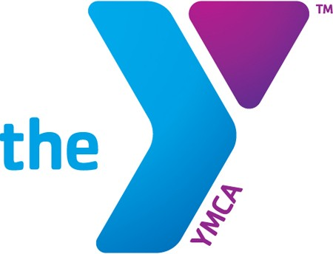
2023 Bath Area Family YMCA Freedom Tour

STUDENT REGISTRATION FORM- Brunswick Junior High
Student Fee: $1350.00* Trip Dates: 6/23/23-6/29/23
*$100 of the fee due at time of Registration

Participant First Name: Last Name: Address: City: State: Zip: Date of Birth: Gender: Cell:__________________ Home: Email Address (PRINT CLEAR): Parent/Guardian Name(s): _______ Phone: Email Address: Parent/Guardian Name(s): Phone: Email Address:
We want to create an environment in which CARING, HONESTY, RESPECT AND RESPONSIBILITY are promoted. Unacceptable behavior will be confronted and treated in a fair and consistent manner by all team leaders, teachers, and staff.

The use of illegal substances, alcohol, drugs, tobacco, and weapons are forbidden and may result in serious consequences as governed by the laws of each state. Consequences because of inappropriate behavior regarding hotel, bus, and event etiquette will be discussed by staff. It will be treated on an individual basis, and consequences will pertain to the behavior.

All students must display appropriate behavior both in and outside of school. Any violation of this may result in removal from the tour.

In the event that my child is excused from the program, either for medical, behavioral or other reasons, the YMCA has my permission to arrange for travel home, which may include airline flight, train, bus or other arranged transportation. I further agree that all expenses related to transportation home will be my responsibility.

I have read and understand the above statements. __________Initials
Health Concerns/Allergies:
I give permission for the YMCA to use, display, and publish, etc. photographs in print and online as part of the Bath Area Family YMCA internet projects.
________________ Initials

2023 Bath Area Family
YMCA Freedom Tour
The fee for the program is $1350. A $100 nonrefundable deposit is due at the time of registration.
Full payment is required one month prior to the trip departure date.
Refunds (other than the nonrefundable deposit) will not be issued if notification is given less than 30 days prior to trip.
We understand that additional material will be sent home regarding dates, meetings, behavior expectations, medical information and activities relating to the Bath Area Family YMCA Freedom Tour. These forms will need to be filled out entirely for your child to be able to attend the program.
We acknowledge that participating in this program requires attending scheduled meetings. I allow my child to participate and will attend parent meetings as scheduled.
Participation in the Freedom Tour is by invitation, after a review and acceptance of your application and your attendance at program planning educational meetings. Program application packets are passed out at the registration meeting. These are due at the 1st parent/student meeting. The Bath Area Family YMCA reserves the right, at any time, to refuse to grant any application, or to rescind any accepted application, for failure to comply with the prerequisites to tour participation, or for behavior which may be deemed detrimental to the trip in any way.
I have read and understand the above statements. __________Initials

We have read this flyer and understand the information. We understand that attending program meetings is required.

For Student: As a representative of my family, school, the YMCA, and our community, adherence to this policy will ensure a successful and enjoyable experience for all involved. I, along with my parent(s) and leaders understand and agree to the principles of good behavior, and fair and consistent discipline.

IN ORDER TO REGISTER FOR PROGRAM, WE MUST HAVE SIGNATURES FROM BOTH GUARDIAN AND STUDENT.

_______________________________ ___________________________________
Signature of Parent/Legal Guardian & Date Signature of Student and Date

_______________________________ ___________________________________
Printed name of Parent /Legal Guardian Printed Name of Student

All people are welcome to the YMCA without regard to race, creed, religion, sex, or ability to pay.

Please send us an application for financial aid. CHECK HERE
Any questions please Contact:
Deb Young
deb@bathymca.org
Bath Area Family YMCA
303 Centre Street Bath, ME 04530
P:207.443.4112 F: 207.443.1079
www.bathymca.org

