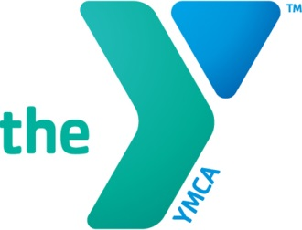 Bath Area Family YMCA Enrichment Program Calendar
2019-2020

September
2– The Y is closed for Labor Day
3—Open House/Orientation for New Families, CHOICES and West Bath Pre-K
4—First day for children with Wrap Around Care
9 – First Day of CHOICES and West Bath Pre-K

October
11 – The Enrichment Classrooms are closed Professional Development
14 – The Enrichment Classrooms are closed Columbus Day

November
8 – No CHOICES or West Bath Pre-K for families that do not use wrap care,
Enrichment 3 classroom closed
11— No CHOICES or West Bath Pre-K for families that do not use wrap care
Enrichment 3 Classroom Closed- Veterans Day
25-29 – No CHOICES or West Bath Pre-K for families that do not use wrap care,
Enrichment 3 Classroom Closed- Thanksgiving Holiday
28-29 – The Enrichment classrooms are closed for Thanksgiving

Ongoing throughout the month – family/teacher conferences

December
23- January 3 – No CHOICES or West Bath Pre-K for families that do not use wrap care
Enrichment 3 Classroom closed
24-25 – Enrichment Classrooms Closed for the Christmas Holiday
31—The Y is closed for New Year’s Eve

January
1—The Y is closed for New Year’s Day
20 – Enrichment classrooms closed for Martin Luther King Day

February
17-21 – No CHOICES or West Bath Pre-K for families that do not use wrap care
Enrichment 3 Classroom Closed

March
6 – Enrichment classrooms closed for professional development
30 –No CHOICES or West Bath Pre-K for families that do not use wrap care
Enrichment 3 Classroom closed

April
20-24 – No CHOICES or West Bath Pre-K for families that do not use wrap care, Enrichment 3 Classroom Closed

May
15—No CHOICES or West Bath Pre-K for families that do not use wrap care
Family/Teacher Conferences
25 – The Y is closed for Memorial Day

Ongoing throughout the month – family/teacher conferences

June
12 – Projected last day for Enrichment 3 classroom, CHOICES and West Bath Pre-K

July
4 – The Y is closed for Independence Day

August

TBD— The Y is closed for Annual YMCA shut down

