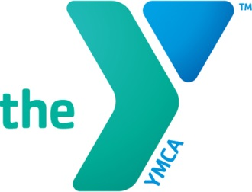 Bath Area Family YMCA Enrichment Program Calendar

September
3– The Y is closed for Labor Day
4 – Orientation for New Families, CHOICES and West Bath Pre-K
5 – First Day of CHOICES and West Bath Pre-K

October
8 – The Enrichment Classrooms are closed for Columbus Day
12- The Enrichment Classrooms are closed for Professional Development

November
6 – No CHOICES for families that do not use wrap care,
Enrichment 3 classroom closed
12- No CHOICES or West Bath Pre-K for families that do not use wrap care
Enrichment 3 Classroom Closed
21-23 – The Enrichment classrooms are closed for Thanksgiving

Ongoing throughout the month – family/teacher conferences

December
24-30 - No CHOICES Pre-K for families that do not use wrap care
Enrichment 3 Classroom closed
24-25 – Enrichment Classrooms Closed for the Christmas Holiday

January
1-4 – No CHOICES Pre-K for families that do not use wrap care
Enrichment 3 Classroom closed
12/31-1/1- Enrichment Classrooms Closed for New Year’s Holiday
20 - Enrichment classrooms closed for Martin Luther King Day

February
18-22 - No CHOICES or West Bath Pre-K for families that do not use wrap care
Enrichment 3 Classroom Closed

March
8 – Enrichment classrooms closed for professional development

April
15-19 - No CHOICES or West Bath Pre-K for families that do not use wrap care, Enrichment 3 Classroom Closed

May
27 – The Y is closed for Memorial Day

Ongoing throughout the month – family/teacher conferences

June
7 – Projected last day for Enrichment 3 classroom, CHOICES and West Bath Pre-K

July
4 – The Y is closed for Independence Day

August
TBD – Annual YMCA shut down week

